Student’s name | …………………………………………………….…… | Grade | 2
Subject | Computer | Week No. | 13
Lesson Title | Pictograph | Unit
Worksheet No. ( 13 )

Question A: State whether ( True ) or ( False )

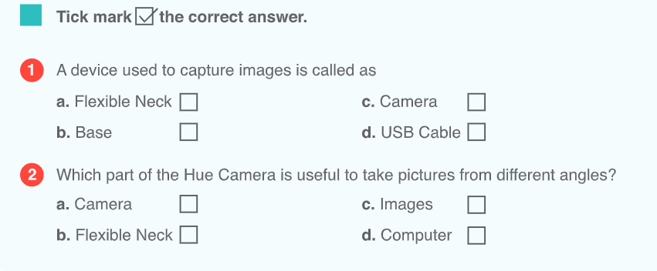
Good Luck

